## **Objectives**

* Explain about React forms
* Define controlled components
* Explain about various input controls
* Explain about handling forms
* Explain about submitting forms

In this hands-on lab, you will learn how to:

* Implement React forms
* Use various input controls like textbox, button and textarea

## **Prerequisites**

The following is required to complete this hands-on lab:

* Node.js
* NPM
* Visual Studio Code

## **Notes**

Estimated time to complete this lab: **60 minutes.**

Create a React App named “ticketraisingapp” which will help to raise a complaint and get it resolved.

Create a component named “ComplaintRegister” with a form containing a textbox to enter the employee name and a textarea to enter the complaint. Use “handleSubmit” event of the button to submit the complaint and generate a Reference number for further follow ups in the alert box.

**Output Expected:**

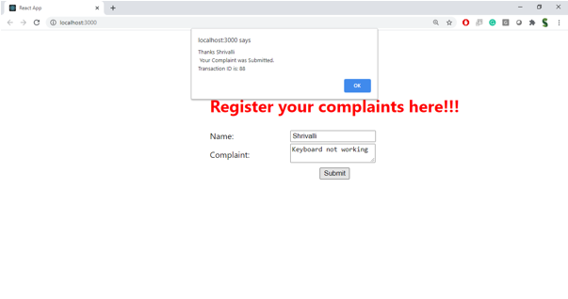

**Hint:**

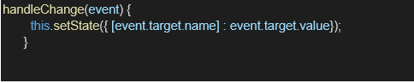

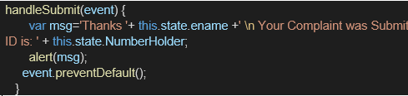

**Solution :**

**Create the React App**

Open your terminal and run:

npx create-react-app ticketraisingapp

cd ticketraisingapp

npm start

**Create the ComplaintRegister Component**

Inside src/, create a file: ComplaintRegister.js

// src/ComplaintRegister.js

import React, { useState } from 'react';

function ComplaintRegister() {

const [employeeName, setEmployeeName] = useState('');

const [complaint, setComplaint] = useState('');

const handleSubmit = (e) => {

e.preventDefault();

if (employeeName.trim() === '' || complaint.trim() === '') {

alert('Please fill all fields');

return;

}

// Generate reference number (random alphanumeric)

const refNumber = 'REF-' + Math.random().toString(36).substring(2, 10).toUpperCase();

alert(`Complaint submitted successfully!\nReference Number: ${refNumber}`);

// Clear the form

setEmployeeName('');

setComplaint('');

};

return (

<div style={{ padding: '20px', maxWidth: '500px', margin: '0 auto' }}>

<h2>Complaint Register</h2>

<form onSubmit={handleSubmit}>

<div>

<label>Employee Name:</label><br />

<input

type="text"

value={employeeName}

onChange={(e) => setEmployeeName(e.target.value)}

style={{ width: '100%', padding: '8px', margin: '8px 0' }}

/>

</div>

<div>

<label>Complaint:</label><br />

<textarea

value={complaint}

onChange={(e) => setComplaint(e.target.value)}

rows="4"

style={{ width: '100%', padding: '8px', margin: '8px 0' }}

></textarea>

</div>

<button type="submit" style={{ padding: '10px 20px' }}>

Submit Complaint

</button>

</form>

</div>

);

}

export default ComplaintRegister;

**Use ComplaintRegister in App.js**

Replace the contents of src/App.js with:

// src/App.js

import React from 'react';

import ComplaintRegister from './ComplaintRegister';

function App() {

return (

<div className="App">

<ComplaintRegister />

</div>

);

}

export default App;